Bug 1:
- Title: A 405 error page when user enters wrong credentials
- Priority: Medium
- Severity: Minor
- Steps to Reproduce:
  - Go to https://wmxrwq14uc.execute-api.us-east-1.amazonaws.com/Prod/Account/LogIn
  - Enter a random user: TestUse01
  - Add any password
  - Click on Log In button
- Expected Result:
A message should be displayed saying:
There were one or more problems that prevented you from logging in:
The specified username or password is incorrect.
- Actual Result:
An HTTP ERROR 405 page is displayed

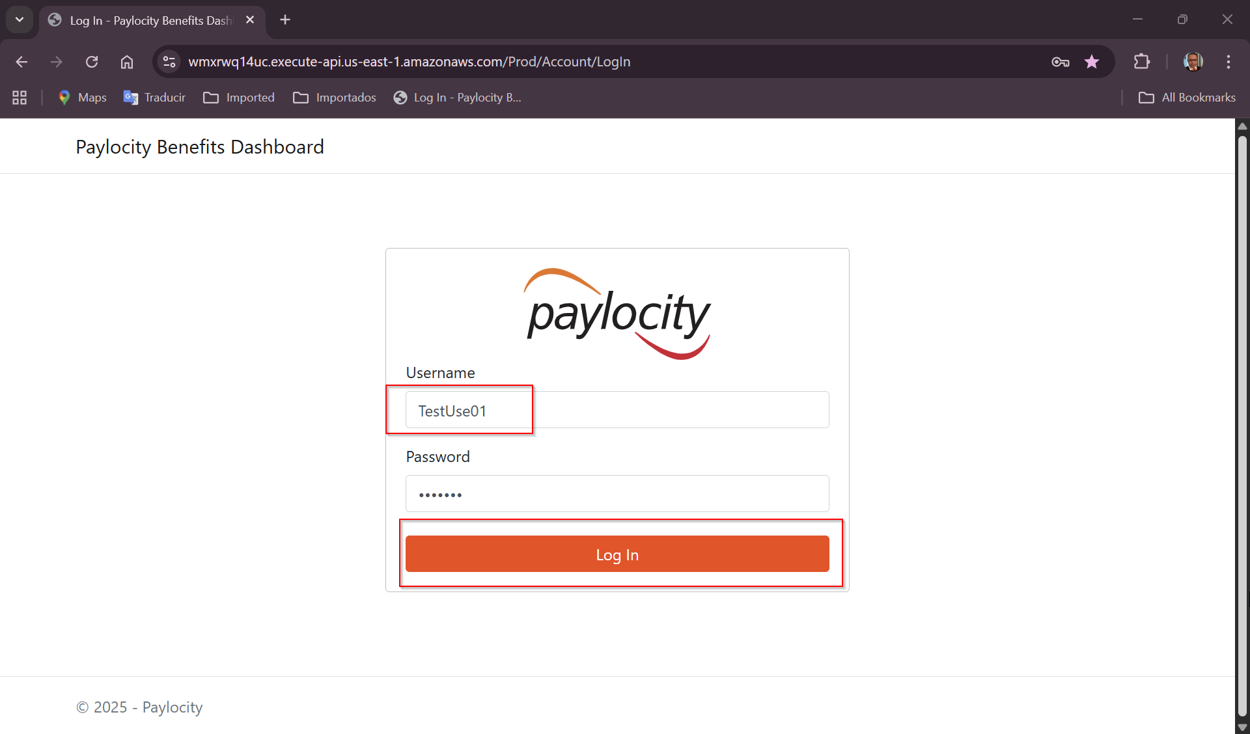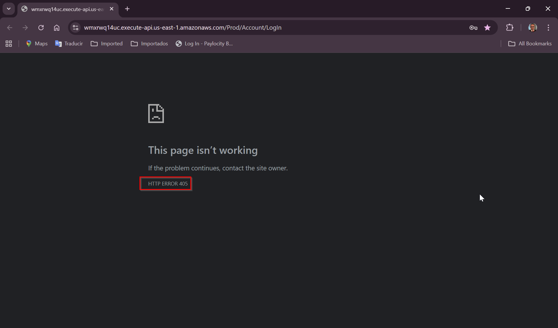

Bug 2:
- Title: Paylocity Benefits Dashboard title is being displayed in login screen
- Priority: Medium
- Severity: Medium
- Steps to Reproduce:
  - Go to https://wmxrwq14uc.execute-api.us-east-1.amazonaws.com/Prod/Account/LogIn
  - Take a look to the title at the top left of the screen
  - Also user is able to click on it
- Expected Result:
Paylocity Benefits Dashbord title shouldn’t being displayed at the top left of the screen
- Actual Result:
Paylocity Benefits Dashboard title is being displayed on Login screen
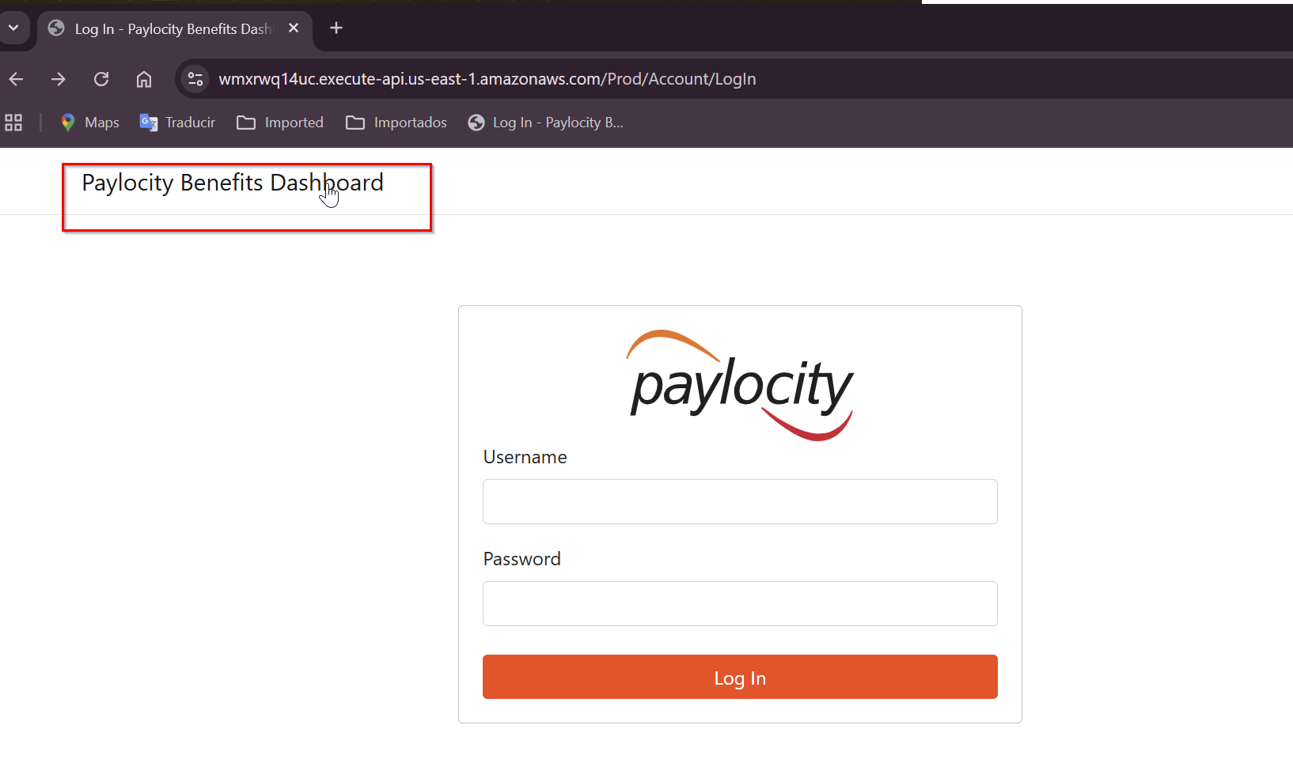

Bug 3:
- Title: First Name and Last Name are not mapped correctly in Dashboard grid
- Priority: High
- Severity: High
- Steps to Reproduce:
  - Go to https://wmxrwq14uc.execute-api.us-east-1.amazonaws.com/Prod/Account/LogIn
  - Login to the application using credentials
  - On Paylocity Benefits Dashboard screen, click on Add Employee
  - On Add Employee pop up, add a first name, last name and dependents
  - Click on Add button
- Expected Result:
A new Employee should be added to the dashboard with correct Last Name and First Name values
- Actual Result:
Last Name and First Name values are incorrect, the First Name is being displayed in Last Name column and the Last Name value is being displayed in the Last Name columna
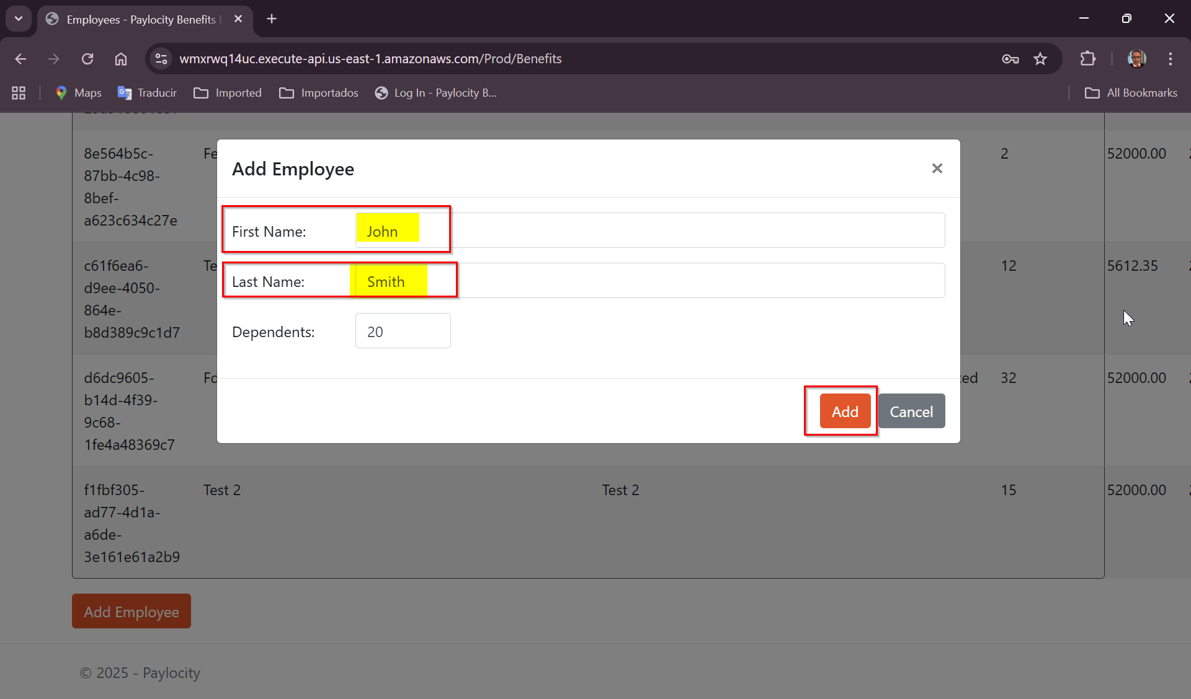
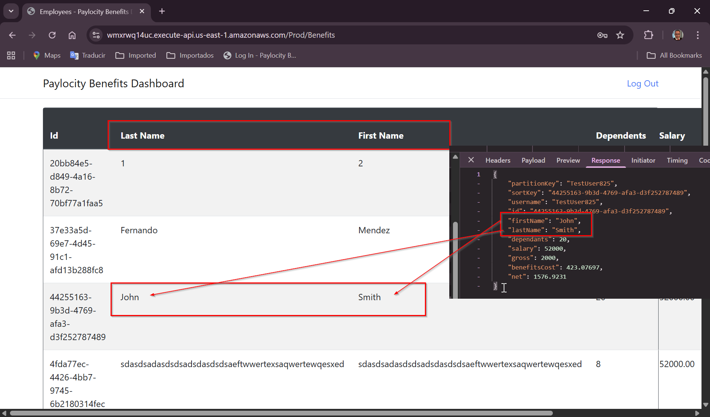

Bug 4:
- Title: Remove link in Paylocity Benefits Dashboard title
- Priority: Medium
- Severity: Low
- Steps to Reproduce:
  - Go to https://wmxrwq14uc.execute-api.us-east-1.amazonaws.com/Prod/Account/LogIn
  - Login to the application using credentials
  - On Paylocity Benefits Dashboard screen, click on Paylocity Benefits Dashboard
  - Same Benefits page is loaded
- Expected Result:
No link should be displayed in the title
- Actual Result:
Paylocity Benefits Dashboard title is displayed as link
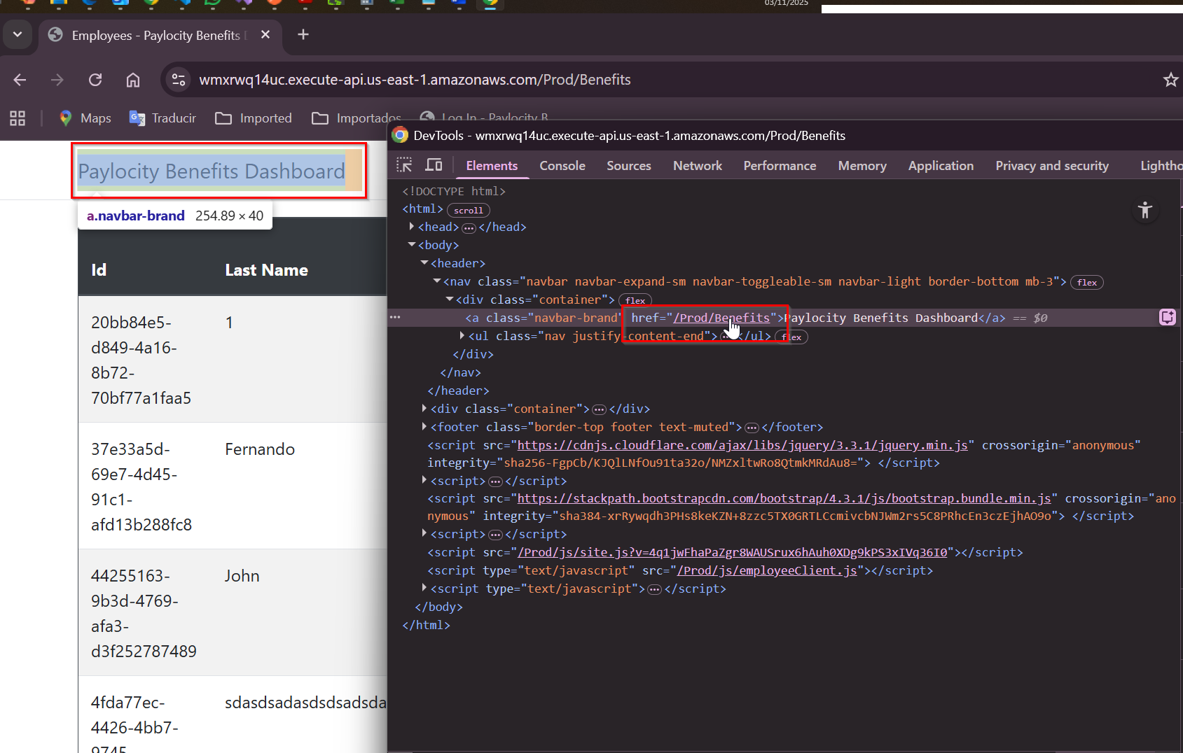

Bug 5:
- Title: Employee ID is displayed as a raw GUID instead of a user-friendly identifier
- Priority: Medium
- Severity: Low
- Steps to Reproduce:
  - Go to https://wmxrwq14uc.execute-api.us-east-1.amazonaws.com/Prod/Account/LogIn
  - Login to the application using credentials
  - Observe the value shown in the ID columna for any employee
- Expected Result:
The ID should be displayed in a user-friendly format, such as:
    - A masked versión (ID: 001, 002)
    - A label like “Employee #123”
    - Or hidden entirly if not relevant to the user
- Actual Result:
The full GUID is showing directly in the UI:
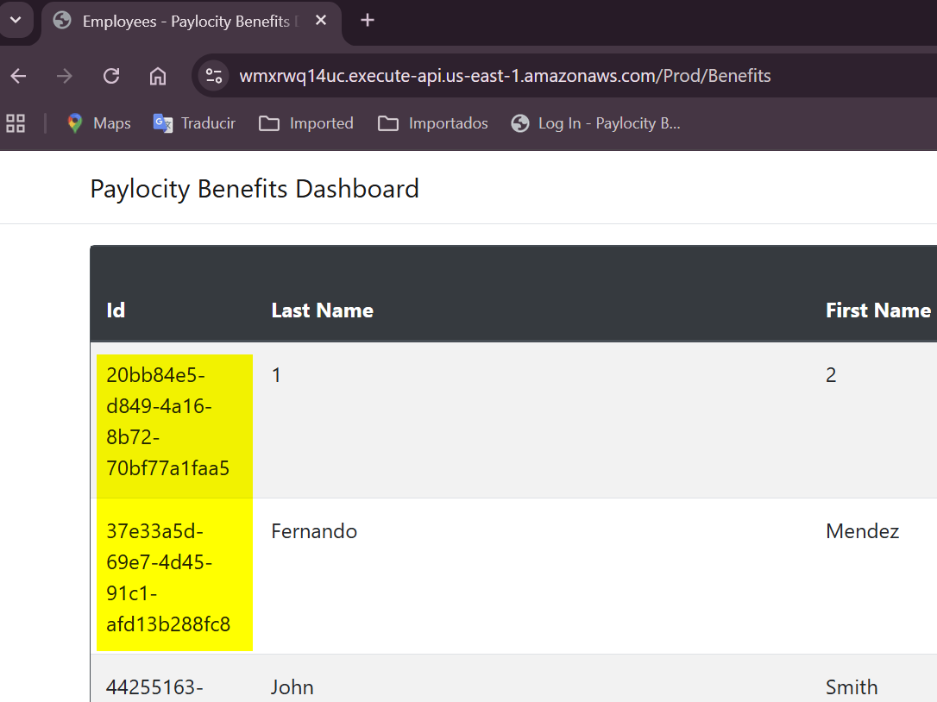

Bug 6:
- Title: Table layout breaks when long Last/First Name values are displayed
- Priority: Low
- Severity: Low
- Steps to Reproduce:
  - Go to https://wmxrwq14uc.execute-api.us-east-1.amazonaws.com/Prod/Account/LogIn
  - Login to the application using credentials
  - On Paylocity Benefits Dashboard screen, click on Add Employee
  - On Add Employee pop up, add a first name (max 50 chars), last name (max 50 chars) and dependents
  - Click on Add button
  - Take a look to the columns
- Expected Result:
Table content should adapt responsively tos creen size and maintain consistent margins
- Actual Result:
Table overlapps when máximum characters are entered in Last or First Name fields
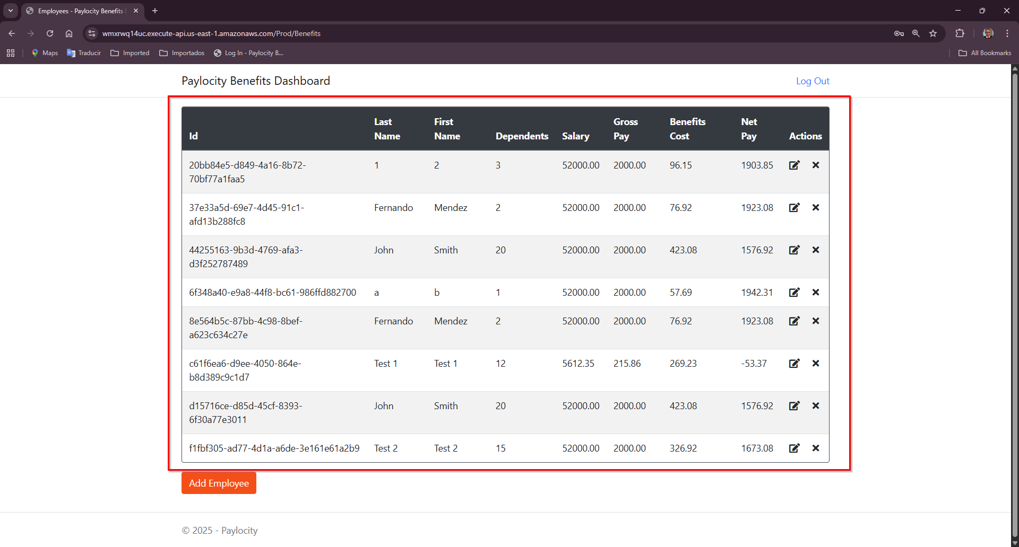
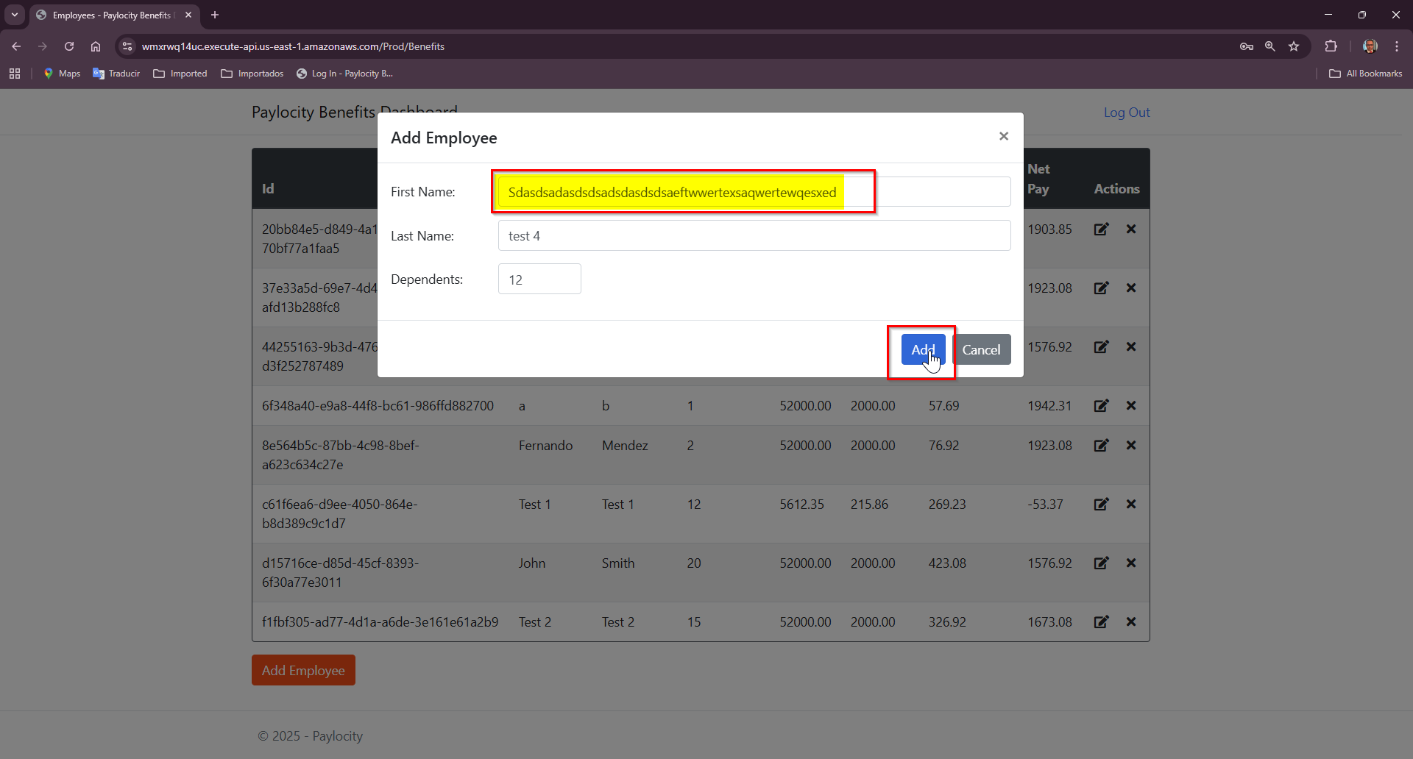
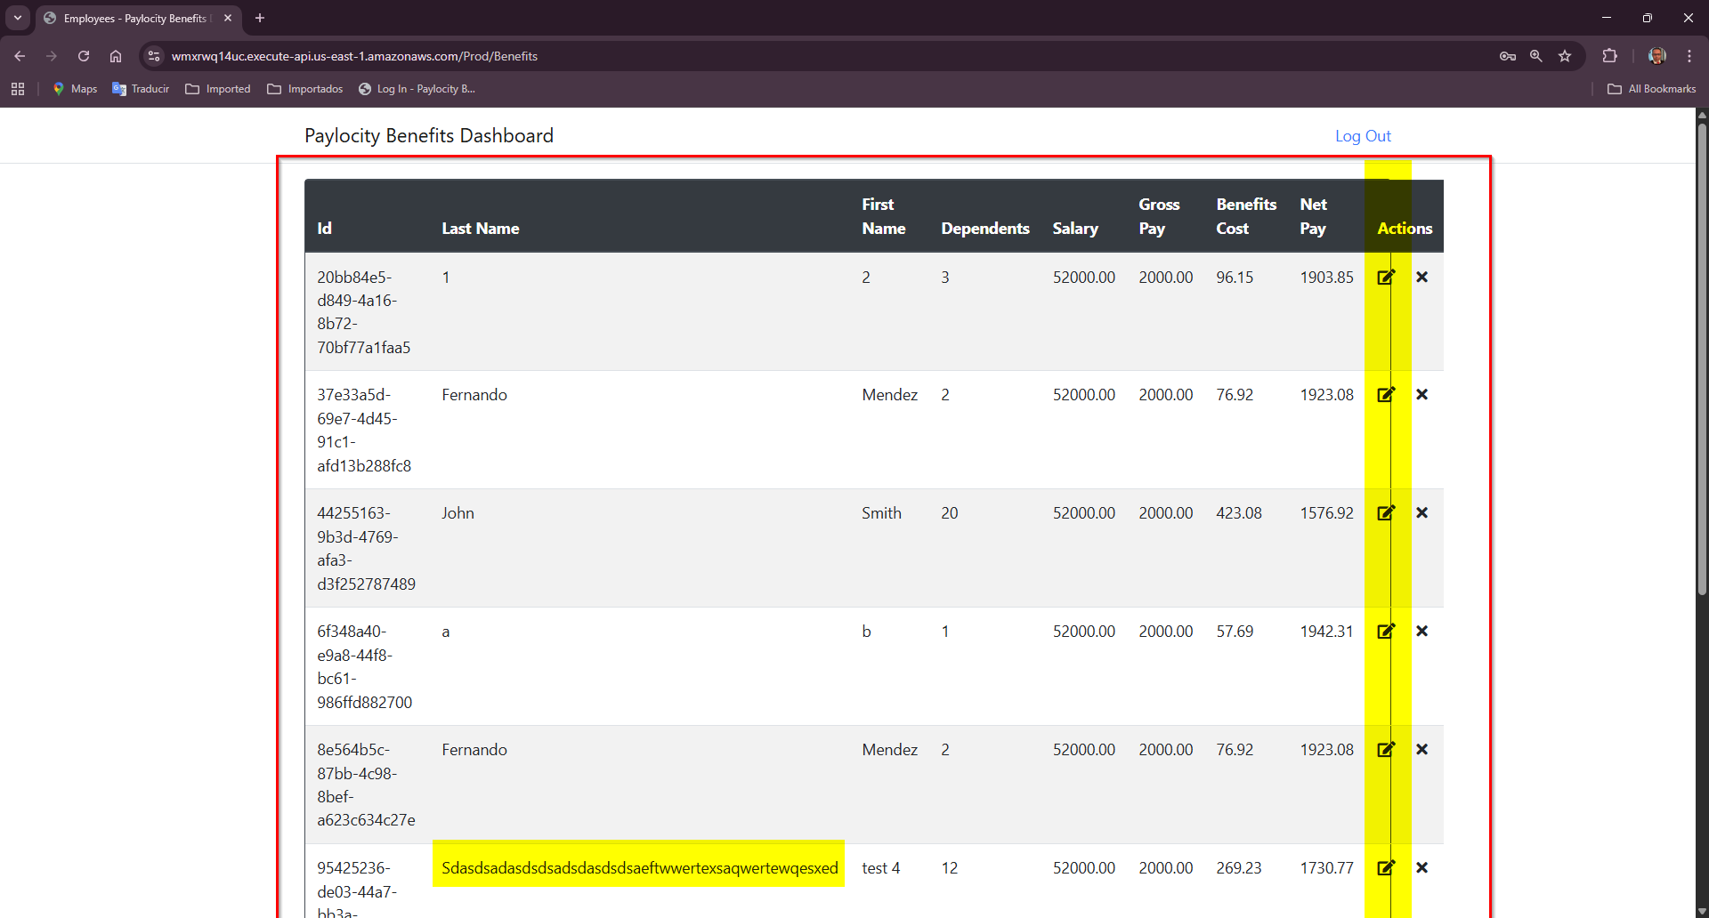

Bug 7:
- Title: No user feedback when session expires (401 unauthorized on employee action)
- Priority: High
- Severity: High
- Steps to Reproduce:
  - Go to https://wmxrwq14uc.execute-api.us-east-1.amazonaws.com/Prod/Account/LogIn
  - Login to the application using credentials
  - On Paylocity Benefits Dashboard screen, click on Add Employee
  - Wait until session has expired (DEV tools -> Aplication -> Cookies -> Expires
  - Click on Add button or delete or update button
  - Nothing happens
  - Go to Dev Tools -> Network
  - Make sure a 401 error is displayed
- Expected Result:
If the session has expired or unauthorized:
    - The system should display a clear message (e.g, “Your sesión has expired. Please log in again”.)
    - The user should be redirected to the login page or given an option to re-authenticate.
- Actual Result:
    - The UI shows no error message.
    - The action silently fails
    - In Dev Tools the request returns:
      - Request Method: DELETE
      - Status Code: 401 Unauthorized
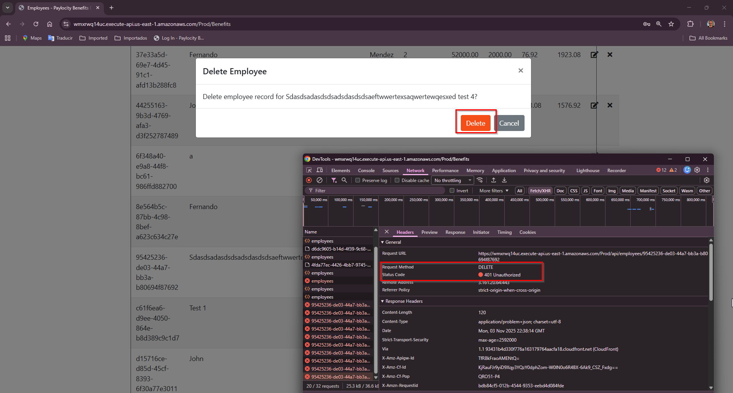

Bug 8:
- Title: Last and First name fields allow special characters and numbers for add employee
- Priority: Medium
- Severity: Medium
- Steps to Reproduce:
  - Go to https://wmxrwq14uc.execute-api.us-east-1.amazonaws.com/Prod/Account/LogIn
  - Login to the application using credentials
  - On Paylocity Benefits Dashboard screen, click on Add Employee
  - On Add Employee pop up, add a first name and last name using special characters: “@$#%$#%"112654” and dependents
  - Click on Add button
- Expected Result:
System should restrict input to alphabetic characters, an error message should be displayed if invalid characters are entered.
- Actual Result:
The fields accpet any type of characters, including numbers and special symbols, no validation or error message is shwon:
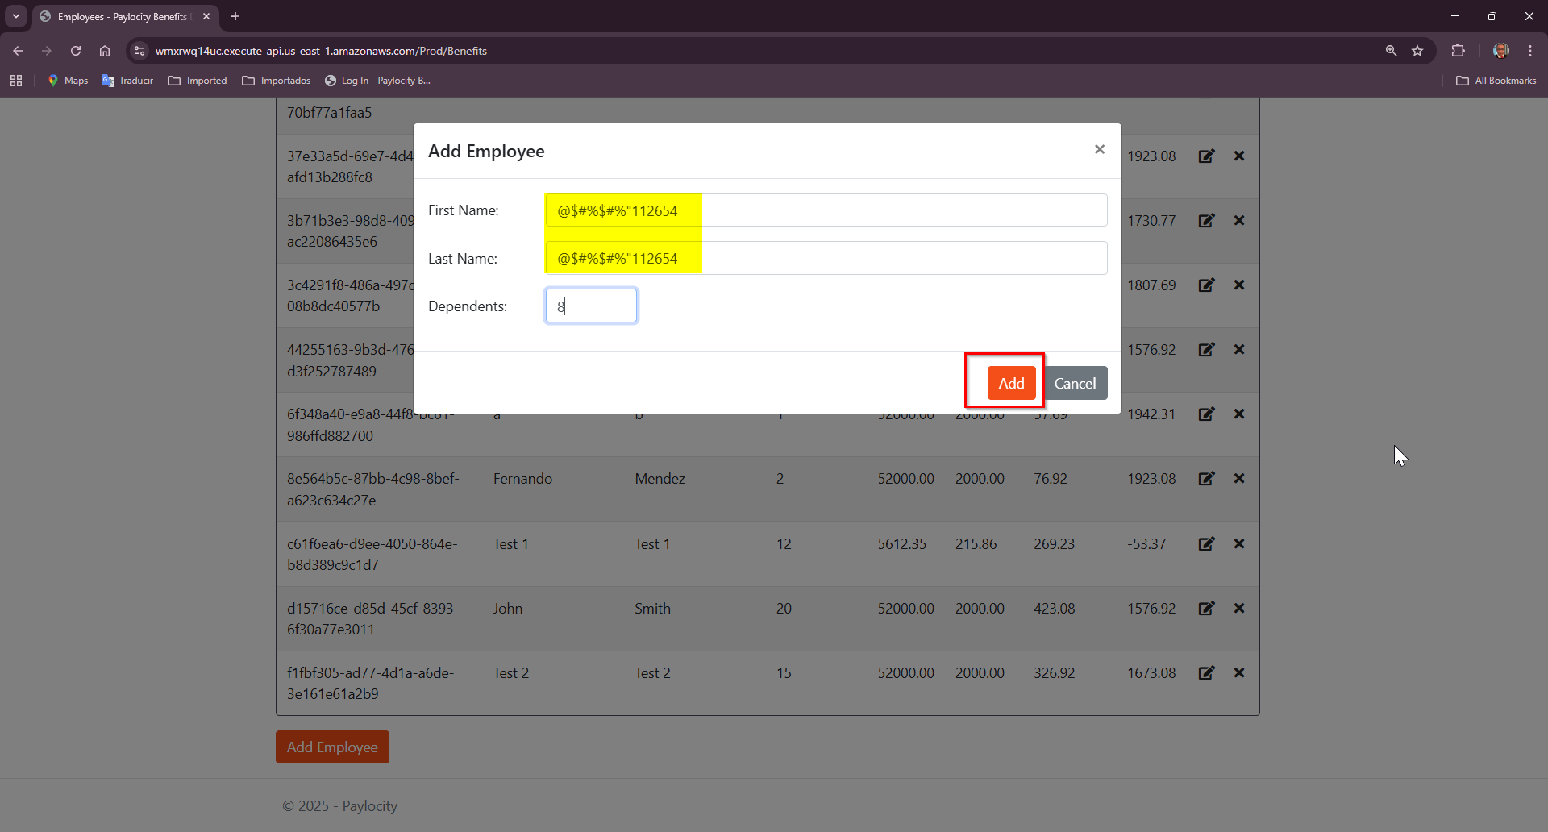
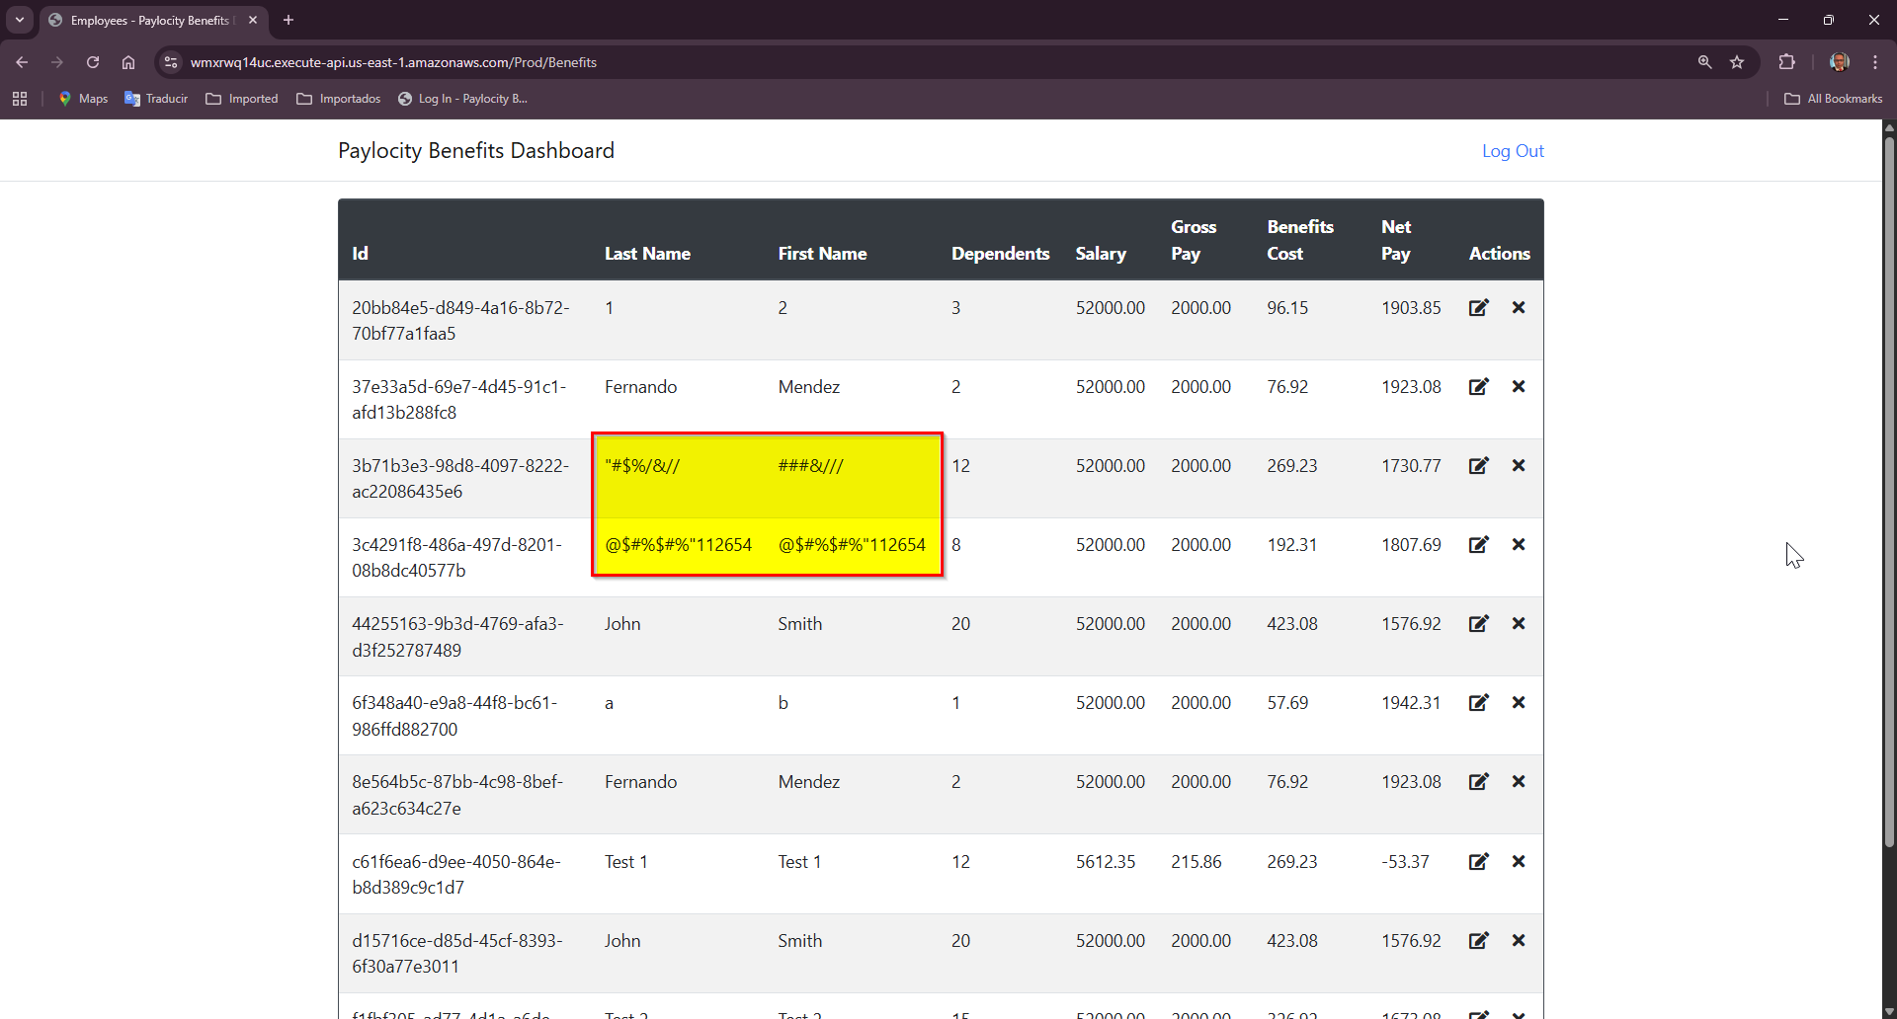

Bug 9:
- Title: Fields in employee pop up should be marked as required on add and update
- Priority: Medium
- Severity: Medium
- Steps to Reproduce:
  - Go to https://wmxrwq14uc.execute-api.us-east-1.amazonaws.com/Prod/Account/LogIn
  - Login to the application using credentials
  - On Paylocity Benefits Dashboard screen, click on Add Employee
  - Do not fill any field
  - Click on Add button
- Expected Result:
    - System should validate required fields before sending the request
    - If fields are empty, the user should see a clear error message such as:
“First Name, Last Name and Dependents fields are requiered”
    - No API call should be made until the form is valid
- Actual Result:
Nothing happens in UI when user tries to add an employee without values. Request is sent as:
{ "firstName": "", "lastName": "", "dependants": null }
API responds:
Status Code: 405 Method Not Allowed

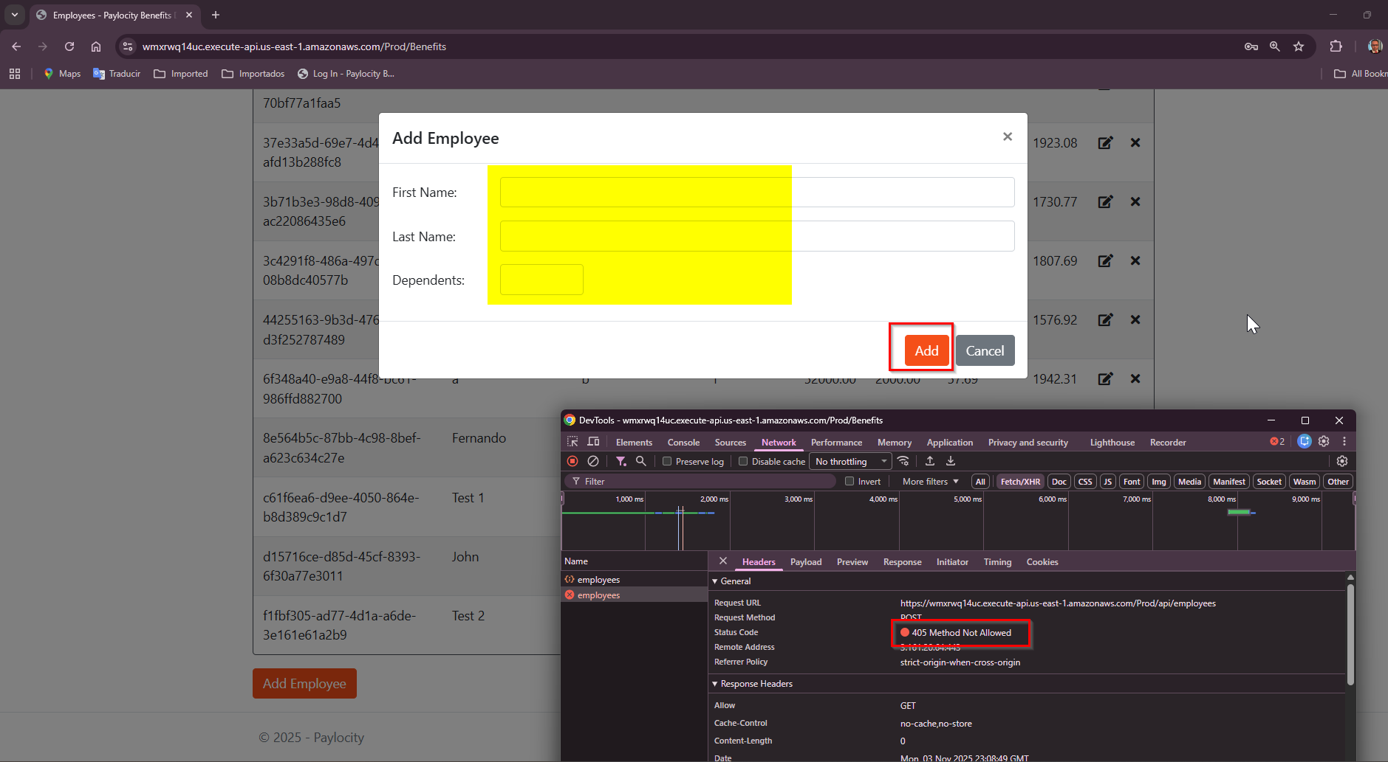

Bug 10:
- Title: Change First and Last Name columns order
- Priority: Low
- Severity: Low
- Steps to Reproduce:
  - Go to https://wmxrwq14uc.execute-api.us-east-1.amazonaws.com/Prod/Account/LogIn
  - Login to the application using credentials
  - On Paylocity Benefits Dashboard screen, take a look to Last Name and First Name columns
- Expected Result:
Column order should be First Name and then Last Name
- Actual Result:
Order column is: Last Name and First Name:
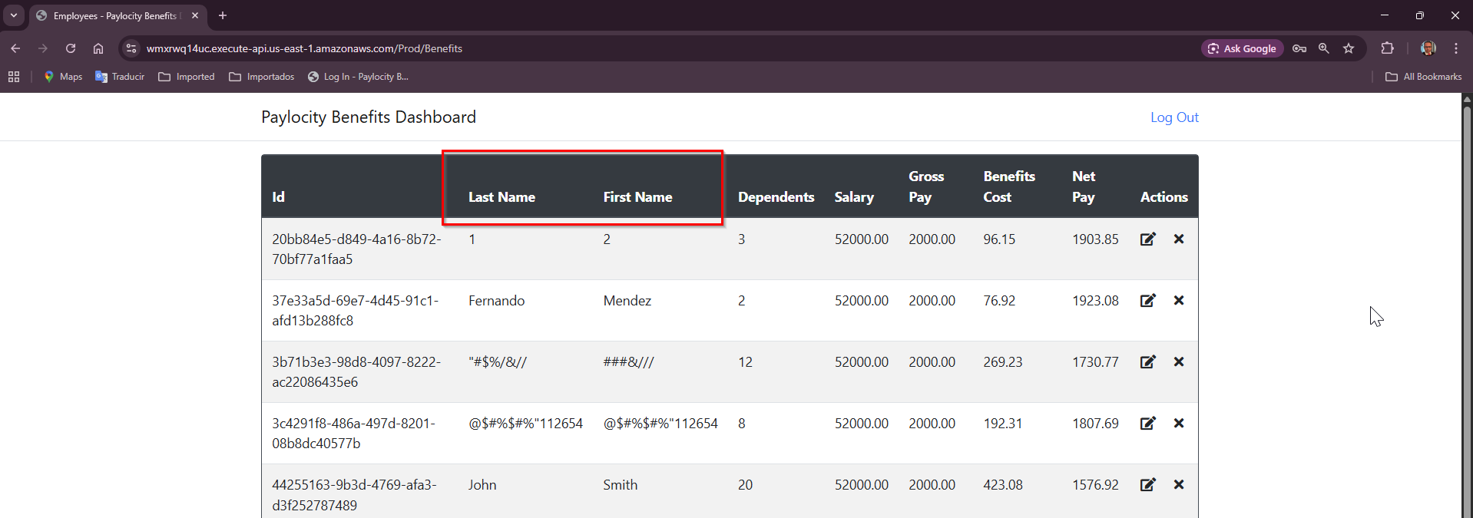

Bug 11:
- Title: No sorting criteria on Paylocity Benefits Dashboard table
- Priority: Medium
- Severity: Medium
- Steps to Reproduce:
  - Go to https://wmxrwq14uc.execute-api.us-east-1.amazonaws.com/Prod/Account/LogIn
  - Login to the application using credentials
  - On Paylocity Benefits Dashboard screen make sure to add at least 4 employees to the table
- Expected Result:
    - Employees should be displayed by ID or Name order automatically once the employee is created
- Actual Result:
    - Employees are not sorted by ID or Name:
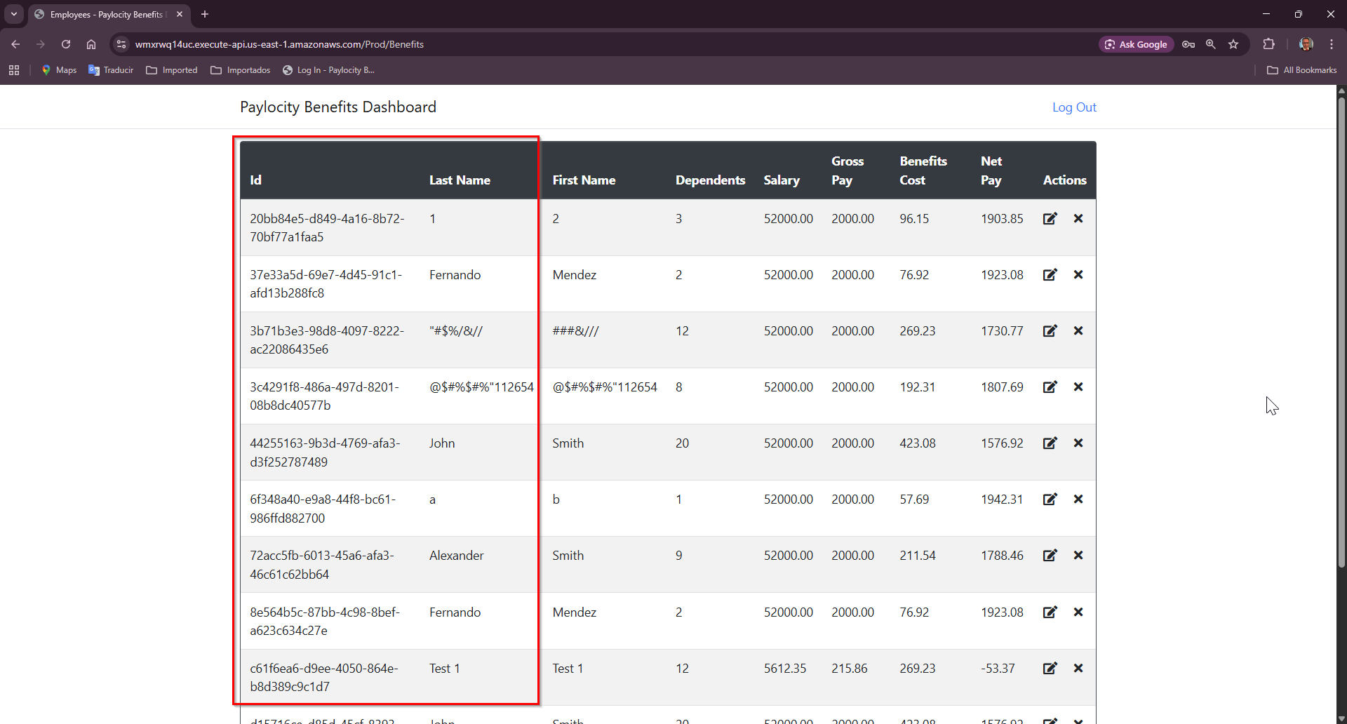

Bug 12:
- Title: Headers should be enabled to sort columns dinamically
- Priority: Medium
- Severity: Medium
- Steps to Reproduce:
  - Go to https://wmxrwq14uc.execute-api.us-east-1.amazonaws.com/Prod/Account/LogIn
  - Login to the application using credentials
  - On Paylocity Benefits Dashboard screen make sure to add at least 4 employees to the table
  - Try to sort by column
- Expected Result:
    - User should be able to sort by any columna in order to get first or last value
- Actual Result:
    - User is no table to sort by any columna
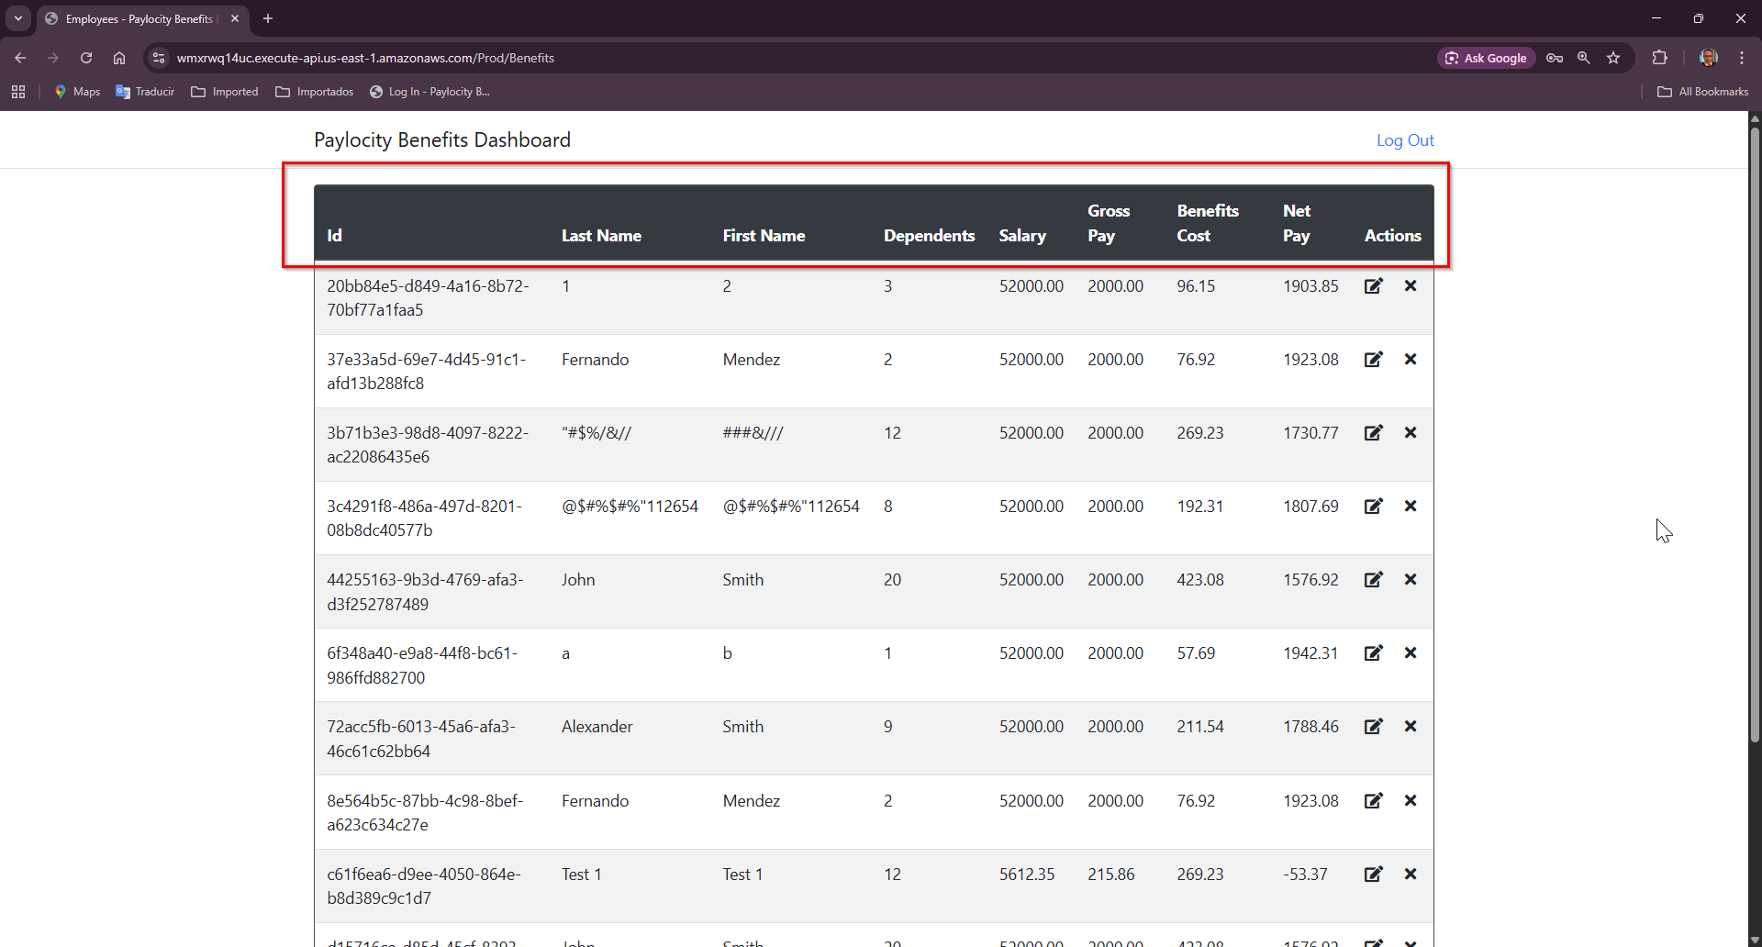

Bug 13:
- Title: Employee table displays all records withouth pagination or row limit
- Priority: Medium
- Severity: High
- Steps to Reproduce:
  - Go to https://wmxrwq14uc.execute-api.us-east-1.amazonaws.com/Prod/Account/LogIn
  - Login to the application using credentials
  - On Paylocity Benefits Dashboard screen make sure to add at least 20 employees to the table
  - Observe the table when a large number of employee records are present
- Expected Result:
    - Table should implement pagination
    - User should be able to navigate between pages or set a custom page size
- Actual Result:
    - All employee records are displayed in a single, scrollable view
    - There’s no pagination, and no limito n the number of rows shown per page
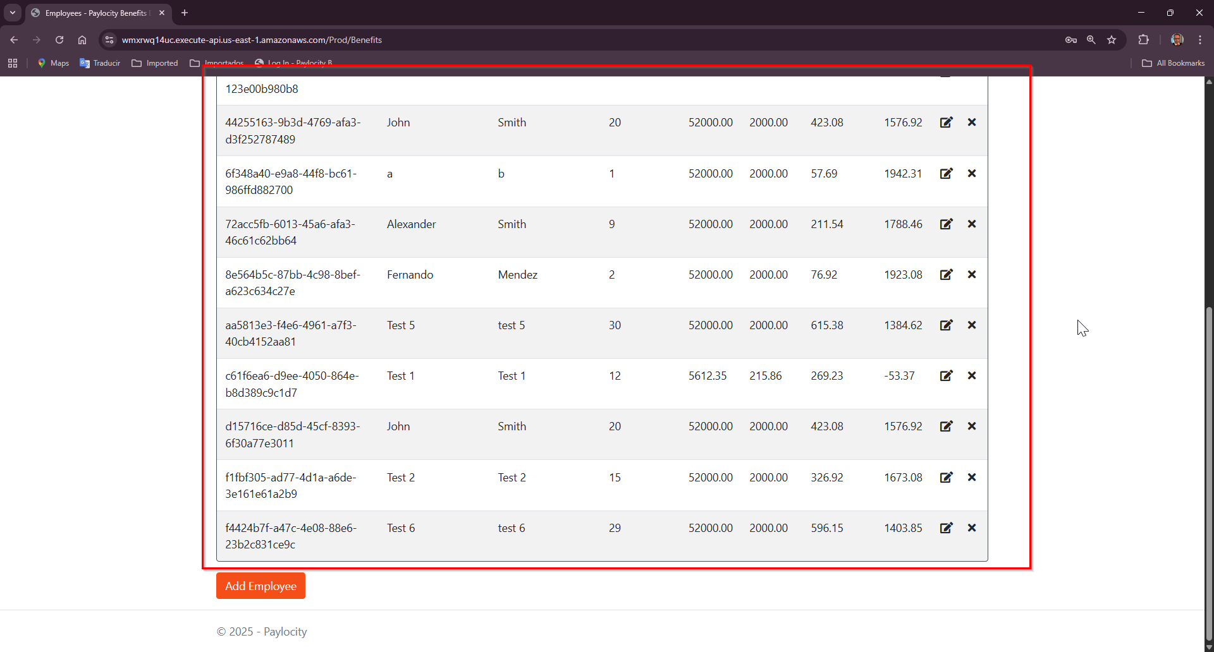

Bug 14:
- Title: Employee table lacks filtering options for key fields
- Priority: Medium
- Severity: High
- Steps to Reproduce:
  - Go to https://wmxrwq14uc.execute-api.us-east-1.amazonaws.com/Prod/Account/LogIn
  - Login to the application using credentials
  - On Paylocity Benefits Dashboard screen make sure to add at least 20 employees to the table
  - Attempt to filter or search by fields
- Expected Result:
    - Table should provide filtering options or a search bar to narrow down results based on user criteria.
    - Filter should support partial matches, numeric ranges or dropdown where applicable
- Actual Result:
    - No filtering or search functionality is available
    - User must manually scroll through all recods, which becomes inefficient with large datasets.

Bug 15:
- Title: Employee table lacks pagination and page size limit
- Priority: Medium
- Severity: High
- Steps to Reproduce:
  - Go to https://wmxrwq14uc.execute-api.us-east-1.amazonaws.com/Prod/Account/LogIn
  - Login to the application using credentials
  - On Paylocity Benefits Dashboard screen make sure to add at least 20 employees to the table
  - Observe the table when a large number of employee records are present
- Expected Result:
    - Table should implement pagination
    - User should be able to navigate between pages or set a custom page size
- Actual Result:
    - All employee records are displayed in a single, scrollable view
    - There’s no pagination, and no limito n the number of rows shown per page
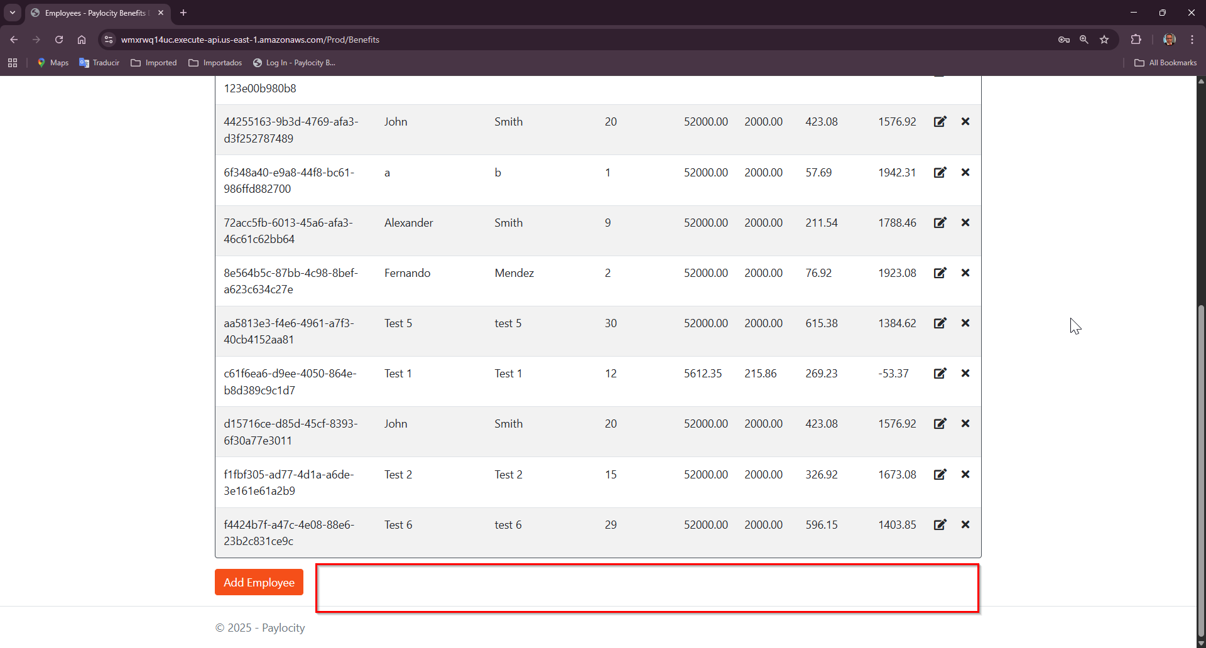

Bug 15:
- Title: Headers should be center aligned
- Priority: Low
- Severity: Low
- Steps to Reproduce:
  - Go to https://wmxrwq14uc.execute-api.us-east-1.amazonaws.com/Prod/Account/LogIn
  - Login to the application using credentials
  - On Paylocity Benefits Dashboard screen, take a look to the headers in the employee table
- Expected Result:
    - Headers should be center aligned
- Actual Result:
    - Headers are left aligned
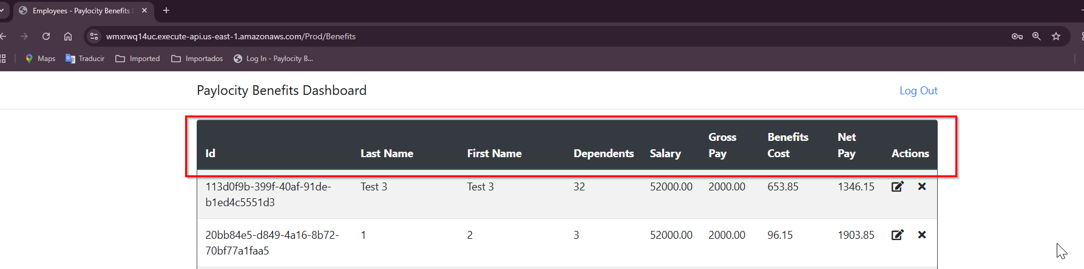

Bug 16:
- Title: Fields in update employee pop up should be marked as required on add and update
- Priority: Medium
- Severity: Medium
- Steps to Reproduce:
  - Go to https://wmxrwq14uc.execute-api.us-east-1.amazonaws.com/Prod/Account/LogIn
  - Login to the application using credentials
  - On Paylocity Benefits Dashboard screen, add a couple of employees and make sure they are displayed in employees table
  - Click on update icon from Actions
  - Clear all fields
  - Click on Add button
- Expected Result:
    - System should validate required fields before sending the request
    - If fields are empty, the user should see a clear error message such as:
“First Name, Last Name and Dependents fields are requiered”
    - No API call should be made until the form is valid
- Actual Result:
Nothing happens in UI when user tries to add an employee without values. Request is sent as:
{ "firstName": "", "lastName": "", "dependants": null }
API responds:
Status Code: 405 Method Not Allowed

Bug 17:
- Title: Title in the pop up should be updated to “Update Employee” when user attempts to update an employee record
- Priority: Medium
- Severity: Medium
- Steps to Reproduce:
  - Go to https://wmxrwq14uc.execute-api.us-east-1.amazonaws.com/Prod/Account/LogIn
  - Login to the application using credentials
  - On Paylocity Benefits Dashboard screen, add a couple of employees and make sure they are displayed in employees table
  - Click on update icon from Actions
  - Take a look to the pop up title
- Expected Result:
    - Title should be displayed as: “Update Employee”
- Actual Result:
Title remains as “Add Employee” when user is updating an employee

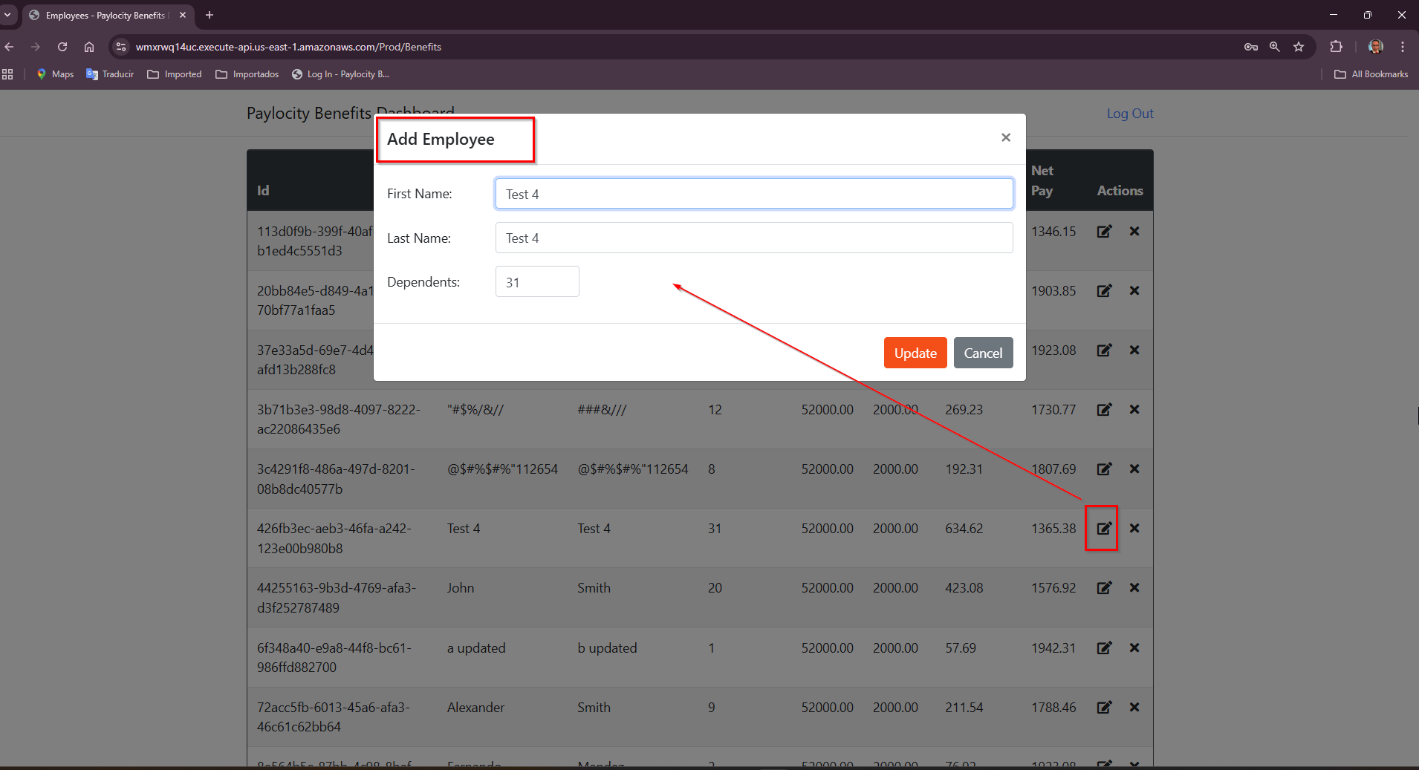

Bug 18:
- Title: After logout, browser back button returns user to dashboard
- Priority: High
- Severity: High
- Steps to Reproduce:
  - Go to https://wmxrwq14uc.execute-api.us-east-1.amazonaws.com/Prod/Account/LogIn
  - Login to the application using credentials
  - Click on Log Out link at the right top of the screen
  - Once Log in page is displayed click on back button from browser
  - User is redirected to the Paylocity Benefits Dashboard page
- Expected Result:
    - Dashboard page should be innaccessible after logout, regardless of browser navigation
    - Session cache should be cleared and protected
- Actual Result:
    - User is redirected back to the Paylocity Benefits Dashboard, even though they are logged out.
    - No re-authentication is required
    - This suggest that sesión cache is not cleared or protected properly
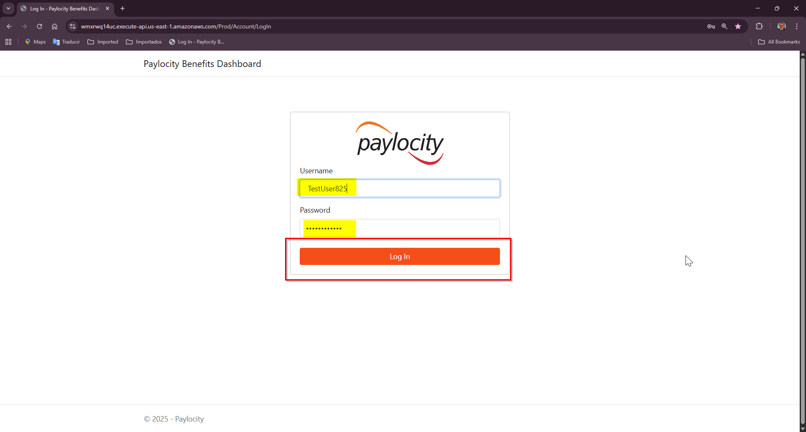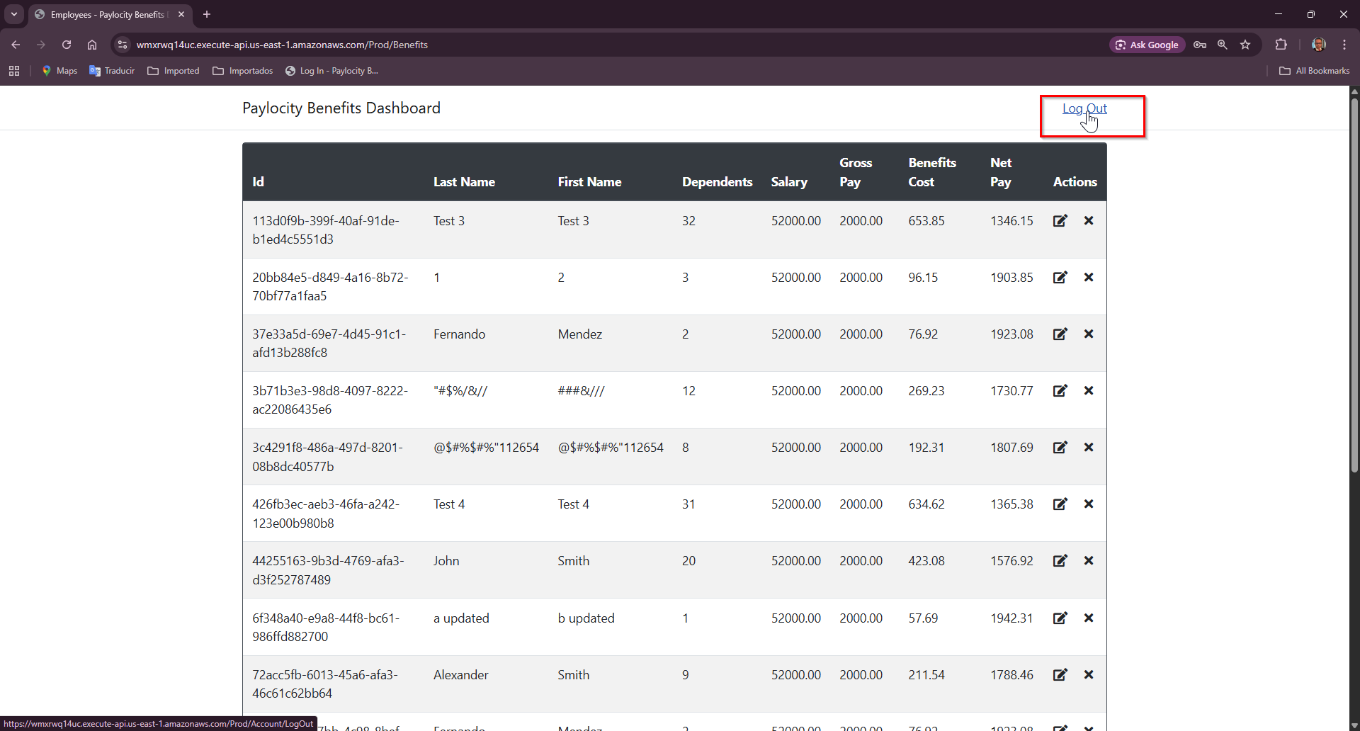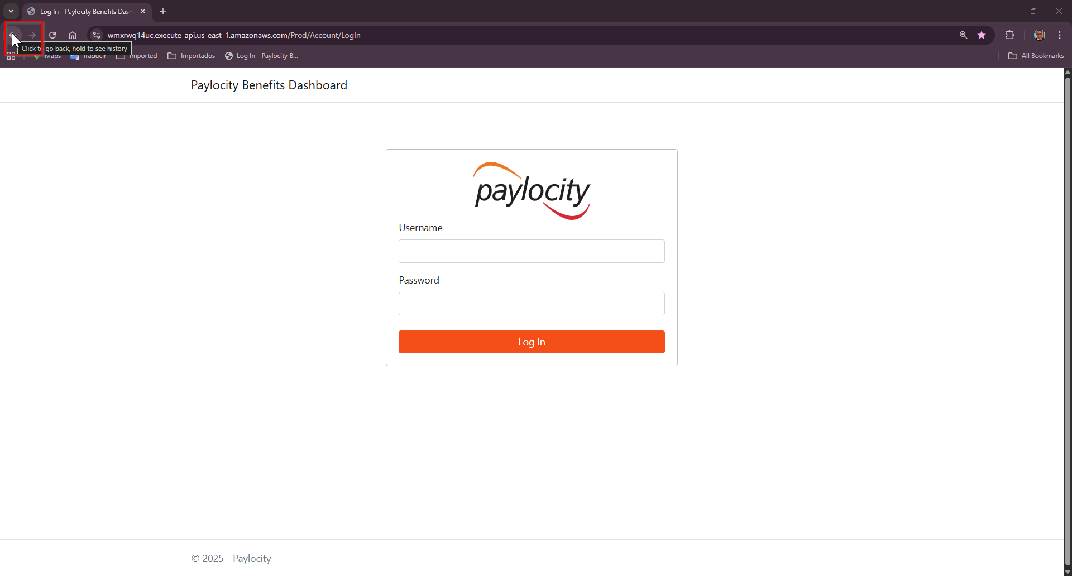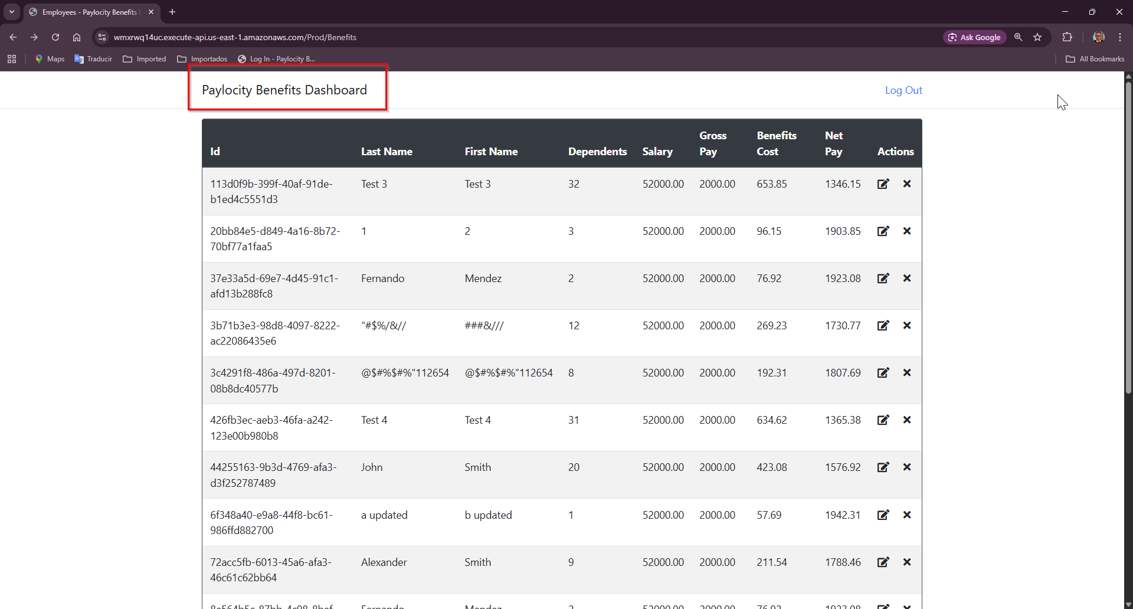

Bug 19:
- Title:Login page doesn’t provide a ‘Forgot Password’ link for account revcovery
- Priority: High
- Severity: High
- Steps to Reproduce:
  - Go to https://wmxrwq14uc.execute-api.us-east-1.amazonaws.com/Prod/Account/LogIn
  - Observe the available options for users who cannot log in
- Expected Result:
    - The login page should include a ‘Forgot Password’ link or button
    - Clicking it should guide the user through a secure password reset process
- Actual Result:
    - No ‘Forgot Password’ option is available
    - Users who forget their credentials have no way to recover Access without external support
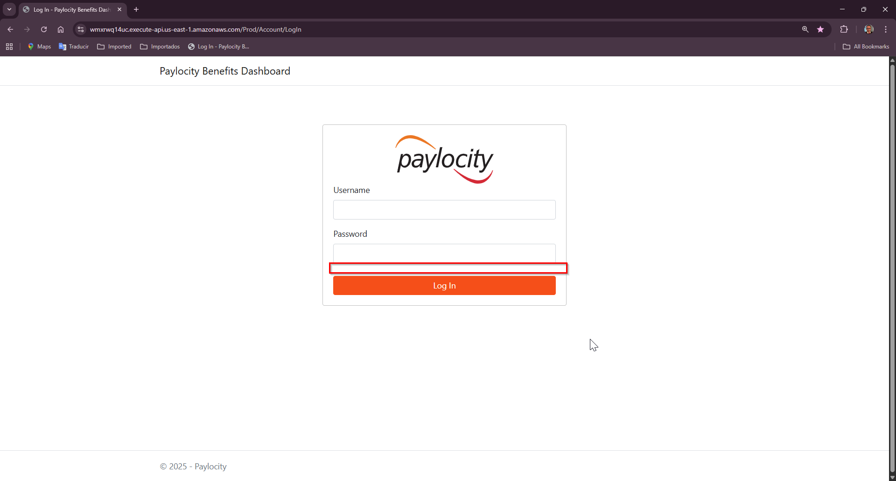

Bug 20:
- Title: No option to remember user credentials on login page
- Priority: Medium
- Severity: High
- Steps to Reproduce:
  - Go to https://wmxrwq14uc.execute-api.us-east-1.amazonaws.com/Prod/Account/LogIn
  - There’s no a checkbox or setting labeled “Remember Me” or “Keep me signed in”
- Expected Result:
    - The login page should offer a “Remember Me” checkbox.
    - When selected, the system should retain login credentials or sesión securely across browser restarts or visits.
- Actual Result:
    - No “Remember Me” options is available.
    - User must re-renter credentials every time they Access the site.

Bug 21:
- Title: Logout action doesn’t promptu ser for confirmation before ending session
- Priority: Medium
- Severity: Medium
- Steps to Reproduce:
  - Go to https://wmxrwq14uc.execute-api.us-east-1.amazonaws.com/Prod/Account/LogIn
  - Login to the application using credentials
  - Click on Log Out link at the right top of the screen
  - Observe the behavior
- Expected Result:
    - The system should display a confirmation dialog before loggin the user out, such as:
“Are yo usure you want to log out?”
    - This prevents accidental session termination and improves user control
- Actual Result:
    - Clicking Log Out immediately redirects the user to the login page.
    - No confirmation or warning is shown
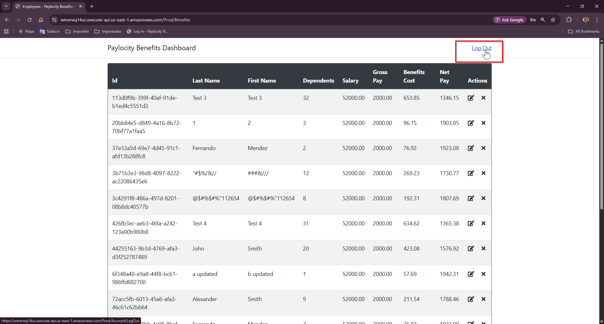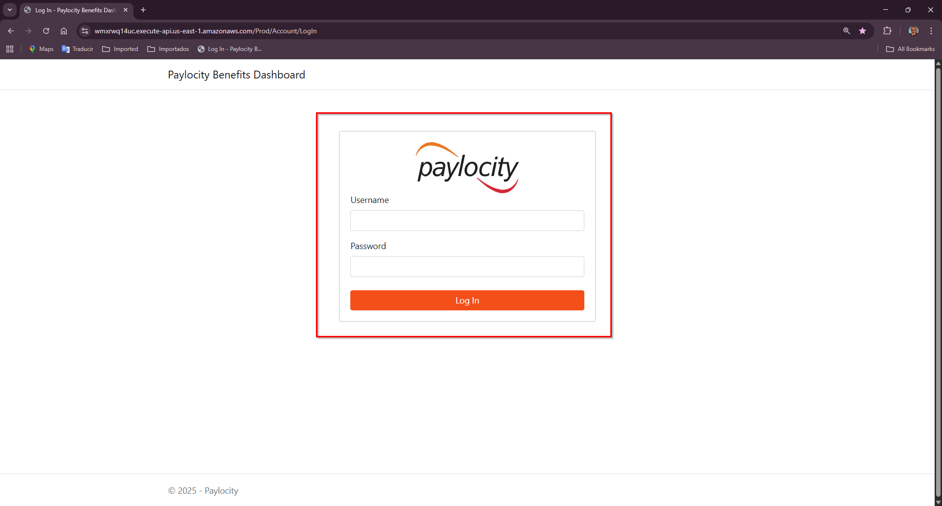

Bug 22:
- Title: Missing tooltips on Update and Delete icons in the action column
- Priority: Low
- Severity: Low
- Steps to Reproduce:
  - Go to https://wmxrwq14uc.execute-api.us-east-1.amazonaws.com/Prod/Account/LogIn
  - Login to the application using credentials
  - On Paylocity Benefits Dashboard page, hover over the Actions buttons: Update and Delete
- Expected Result:
    - Each icon should display a tooltip on hover, such as:
      - “Edit Employee”
      - “Delete Employee”
    - This helps users understand the purpose of each icon, especially if the icons are not labeled.
- Actual Result:
    - No tooltip appears when hovering over the icons.
    - User may be unsure of the icon’s function, specially on smaller screens or for accesibility users.
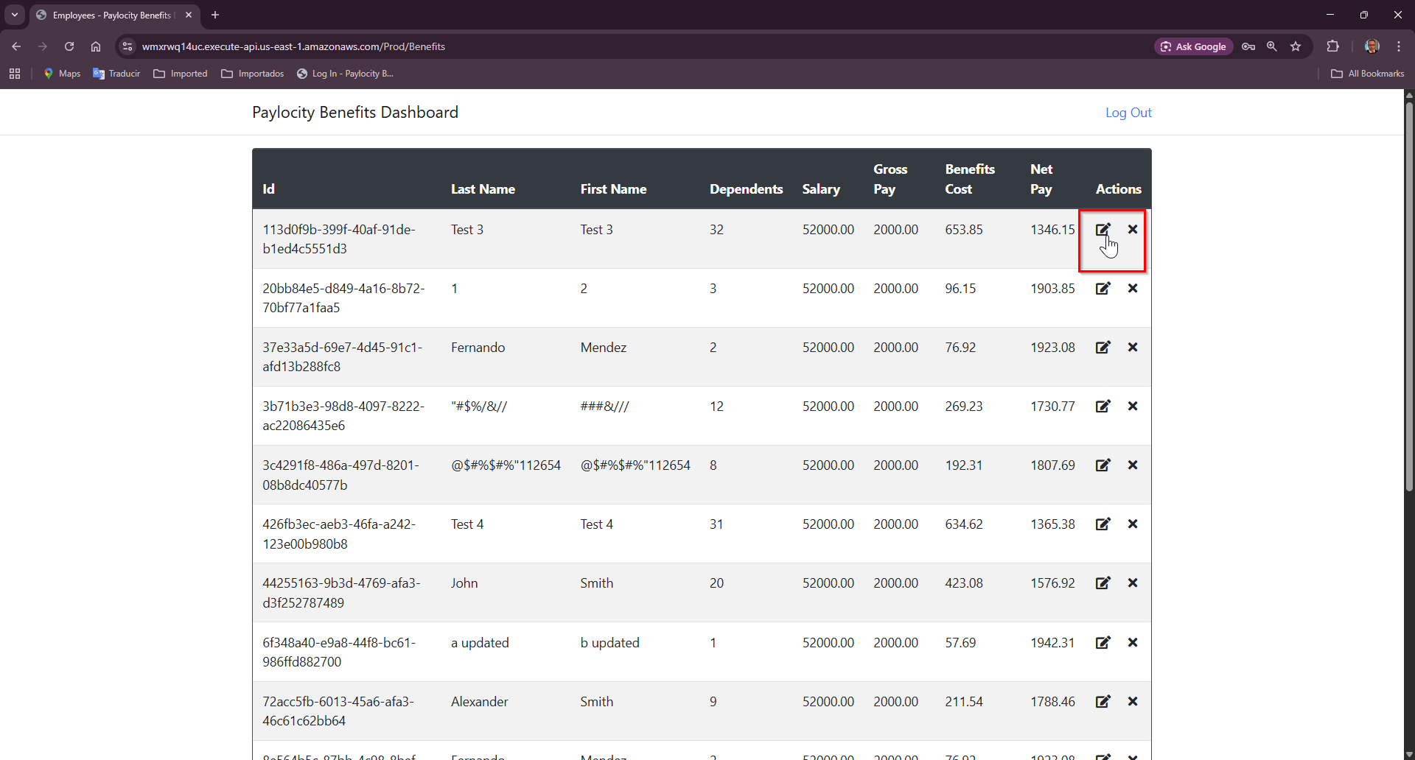
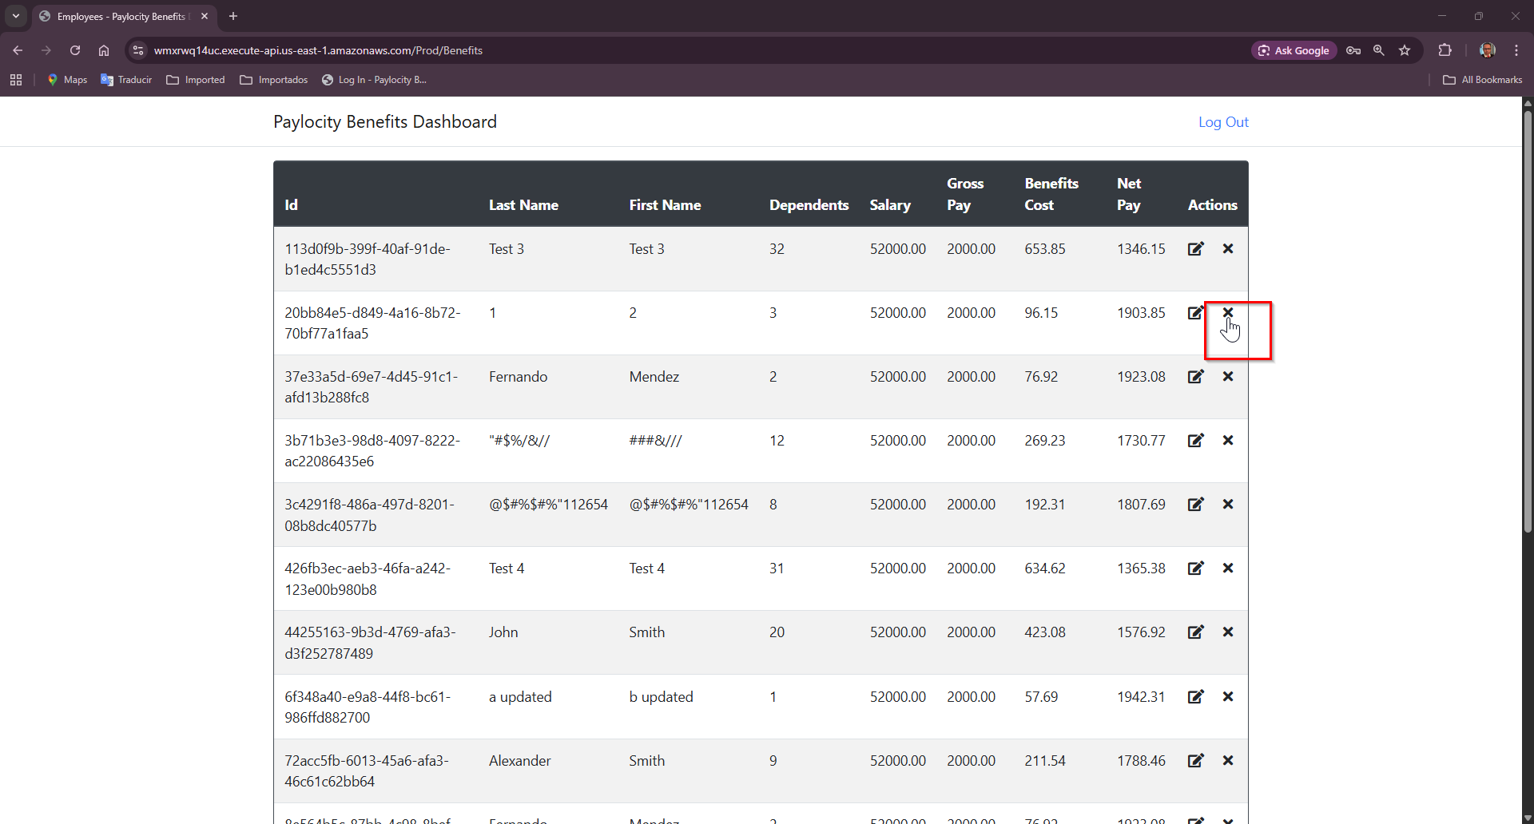

Bug 23:
- Title: ‘Add Employee’ button should be alocated at the top of the dashboard instead of the bottom of the dashboard
- Priority: Medium
- Severity: Medium
- Steps to Reproduce:
  - Go to https://wmxrwq14uc.execute-api.us-east-1.amazonaws.com/Prod/Account/LogIn
  - Login to the application using credentials
  - On Paylocity Benefits Dashboard page, locate the Add Employee button
- Expected Result:
    - Add Employee button should be placed in a prominent, easily accesible location, such as:
      - Top-right/left corner of the table
    - This improves visibility and reduces scrolling effort.
- Actual Result:
    - The button is located at the bottom of the page, requiring users to scroll past all records to access it.
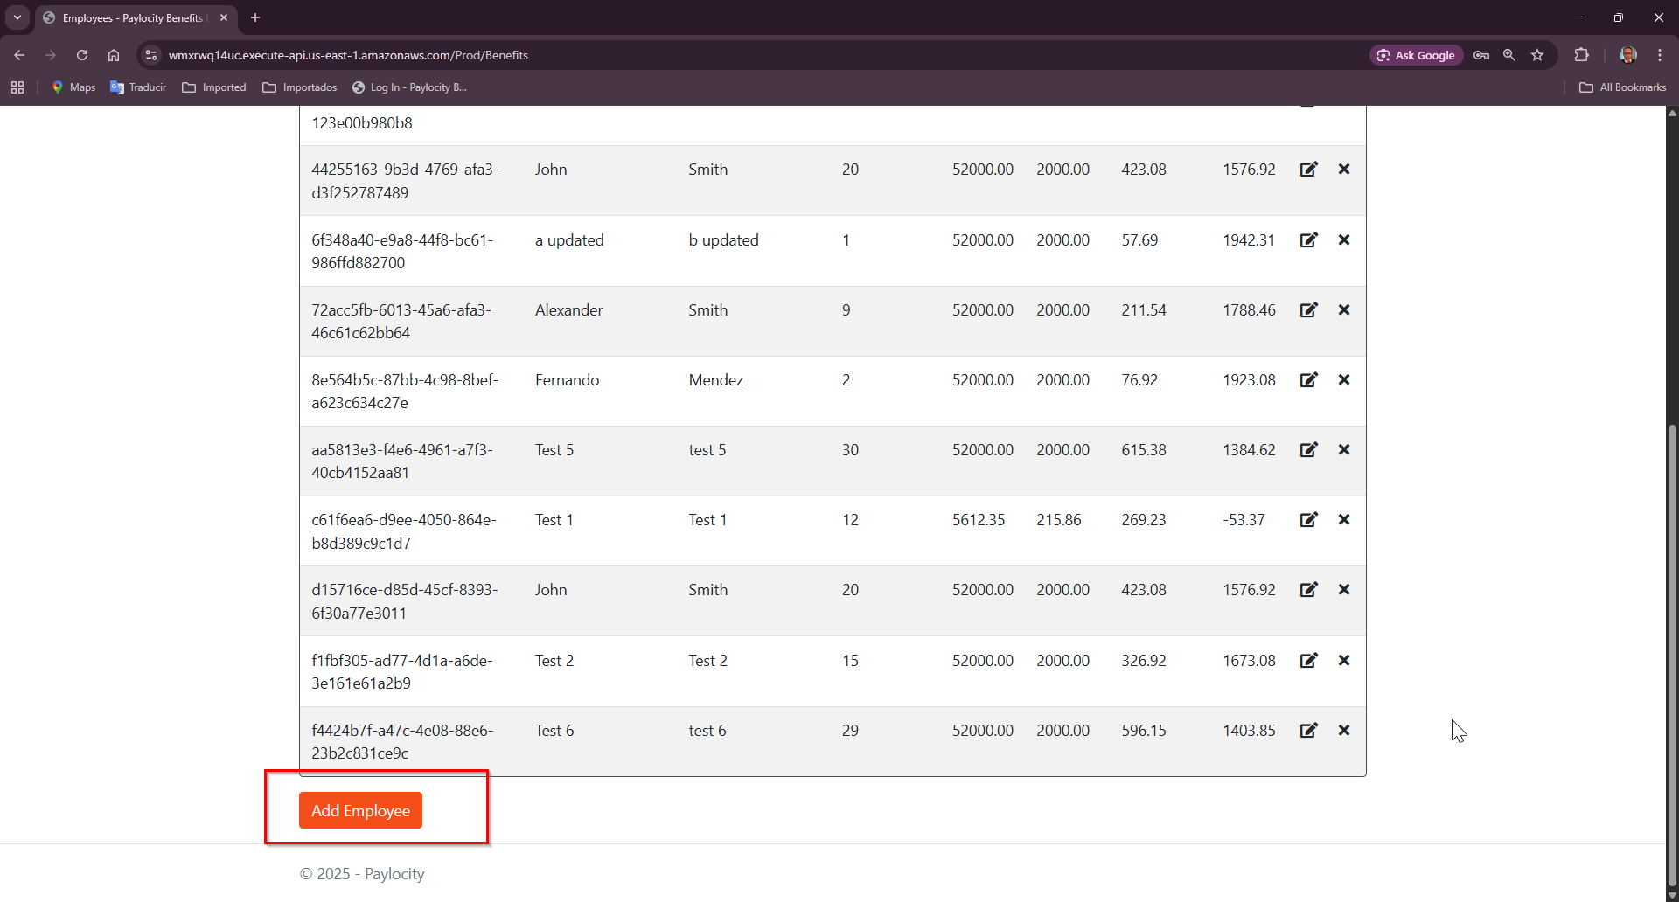

Bug 24:
- Title: No Export table feature available
- Priority: Low
- Severity: Low
- Steps to Reproduce:
  - Go to https://wmxrwq14uc.execute-api.us-east-1.amazonaws.com/Prod/Account/LogIn
  - Login to the application using credentials
  - On Paylocity Benefits Dashboard page, try to export dashboard table
- Expected Result:
    - User should have the ability to export dashboard table.
- Actual Result:
    - There’s no functionality to allow user to export the datatable
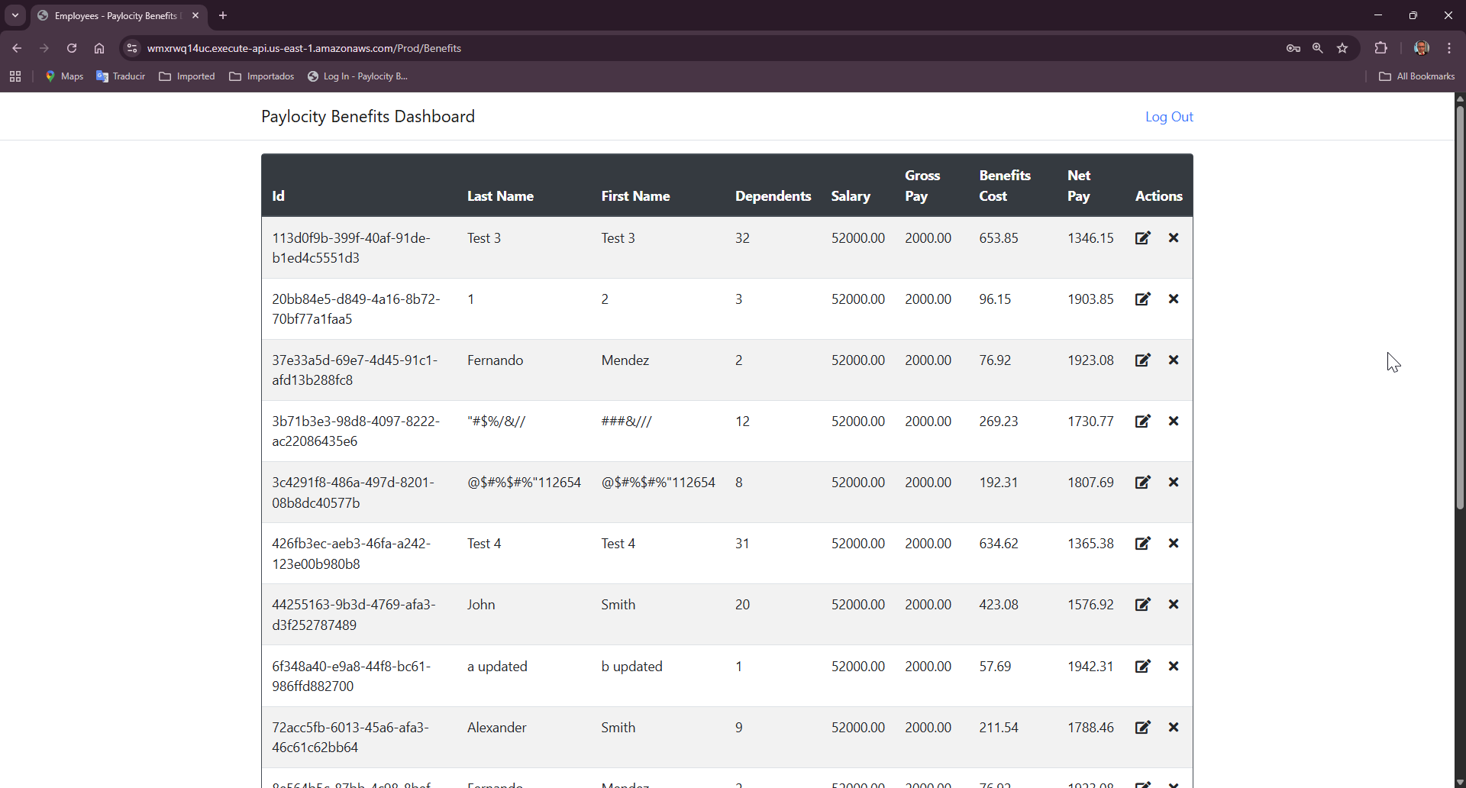

Bug 25:
- Title: No warning message for exceeding field limits on Add and Update employees
- Priority: High
- Severity: High
- Steps to Reproduce:
  - Go to https://wmxrwq14uc.execute-api.us-east-1.amazonaws.com/Prod/Account/LogIn
  - Login to the application using credentials
  - On Paylocity Benefits Dashboard screen, click on Add Employee
  - Enter more than 50 chars in First and Last Name fields
  - Add 33 in dependents
  - Click on Add button
- Expected Result:
    - Display a clear validation message when user excedes these limits:
    - “First Name cannot exceed 50 character”
“Last Name cannot exceed 50 character”
“Dependents must be between 0 and 32”
- Actual Result:
    - Nothing happens when the user excedes First, Last name and Dependents fields
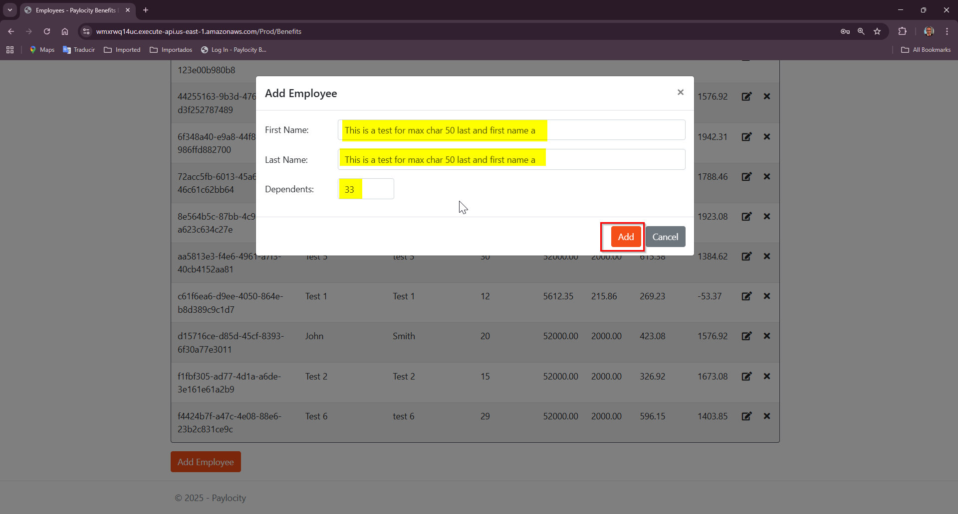
    - Only response shows the information:
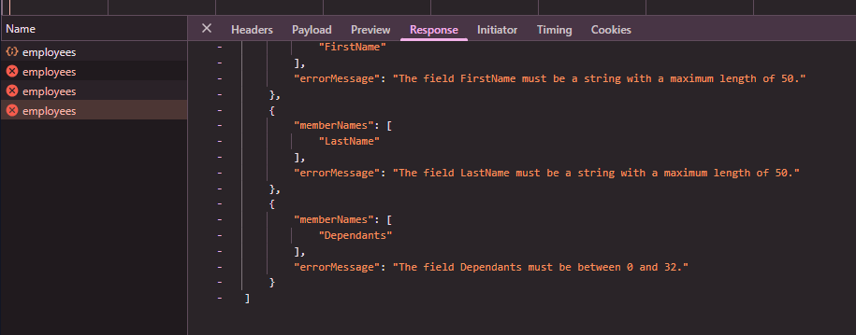

Bug 26:
- Title: Dashboard table doesn’t provide column visibility or customization options
- Priority: Low
- Severity: Low
- Steps to Reproduce:
  - Go to https://wmxrwq14uc.execute-api.us-east-1.amazonaws.com/Prod/Account/LogIn
  - Login to the application using credentials
  - On Paylocity Benefits Dashboard screen, attempt to hide, reorder or resize columns
- Expected Result:
    - The table should provide column options, such as:
      - Show/hide specific columns
      - Reorder columns by drag and drop
      - Resize column widhts
- Actual Result
    - No column options are available
    - All columns are fixed, and users cannot adjust visibility, order, or width
